

MPU3323

WEB APLLICATION DEVELOPMENT

ASSIGNMENT 2

TITLE: MMU FORUM

LECTURER NAME: AZIAH BINTI ALI

GROUP NUMBER: 13

**CHAPTER 1 INTRODUCTION**

MMU Forum is a web application that aims to provide a platform for mmu students or lecturers to be able to discuss and communicate with each other. MMU has a lot of website such as MMLS, mmu portal, camsys and many more but none of them provide a platform to discuss about MMU in general. There will be three types of users, lecturer/staff, students and admin. Student and lecturer will be able to create the topic but lecturer will be able sticky their post which will make their post stay on top. Admin can do what lecturer and student able to but only admin can ban other user. With this application, student and lecturer should be able to learn, help and communicate with each other more easily than ever before.

**CHAPTER 2 PROBLEM STATEMENT**

MMU has many websites but none of them act as a platform that allow MMU student/lecturer to discuss about MMU in general.

**CHAPTER 3 OBJECTIVES**

* To build a platform that allow student and lecturer to discuss about MMU.
* To build a platform that allow student and lecturer not only to share their knowledge but also help others.
* To provide a platform that will connect MMU students/lecturer together.

**CHAPTER 4 TASK DIVISION**

|  |  |  |  |
| --- | --- | --- | --- |
| No. | Student ID | Name | Tasks |
| 1 | 1141127819 | YISAU, ZAIDEE | * Register function * New post/topic function * Reply function |
| 2 | 1171303704 | KARIM DANIAL BIN MOHD SHAIF | * HTML and CSS for sport and hostel page |
| 3 | 1161100832 | MUHD SYAZWAN AQRIMI BIN SUHAIMI | * Ban function * Sticky function |
| 4 | 1161100407 | MOHAMED NIZAR BIN SHAMSUDDIN | * HTML and CSS for games and fitness page |
| 5 | 1151102384 | MUHAMMAD HAFIZ BIN ALIMARIZAN | * HTML and CSS for question&answer and multimedia page |

**CHAPTER 5 SOLUTION**

## 5.1 Use case diagram

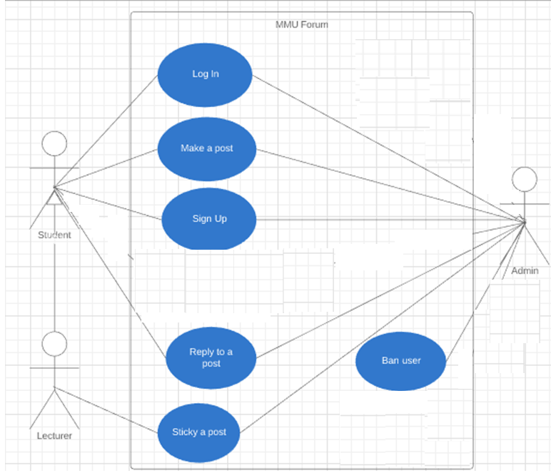

*Figure 5.1: Use case*

## 5.2 Requirement

***5.2.1 Functional Requirement***

* Student and lecturer should be able to make a new post/topic
* Student and lecturer be able to register an account
* Student , lecturer and admin should be able to reply to a post
* Admin should be able to ban user
* Lecturer and admin should be able to sticky their post

***5.2.2 Non-Functional Requirement***

* User Friendly – Simple and easy interface for user to operates.
* Reliability – System should operates without failure most of the time.
* Performance- System should be efficient and respond fast to the user requests.

## 5.3 Placement of elements

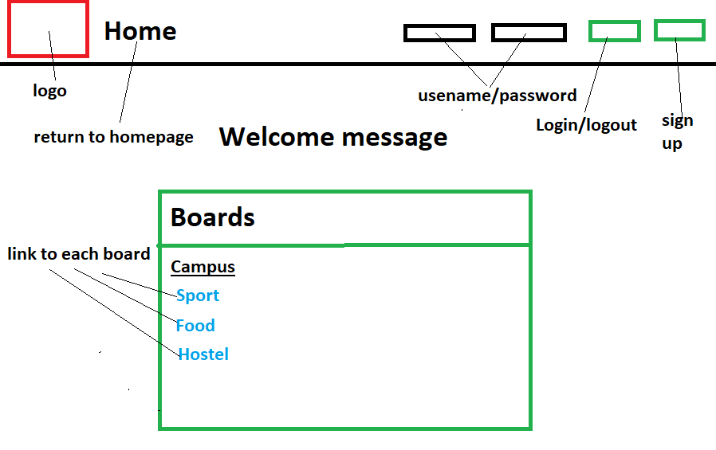

*Figure 5.2: Homepage elements placement*

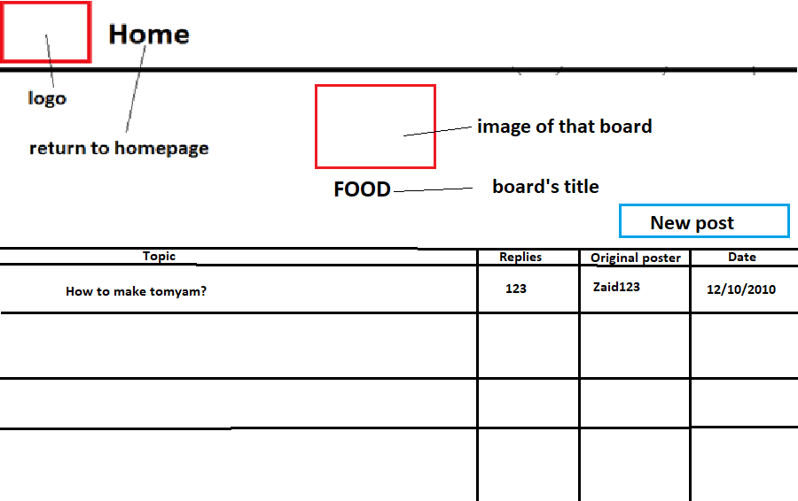

*Figure 5.3: Board page elements placement*

## 5.4 Navigational flow

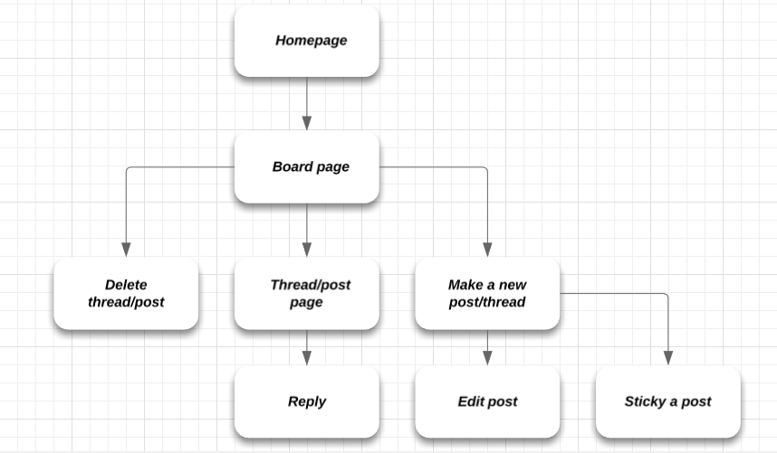

*Figure 5.4: Flow*

## 5.5 Intuitive design

The design for user interface will be based on existing forum/board so that the user can easily learn how to use the website. The button will be labelled clearly with what function they do. Hyperlinks to other page will be highlighted when hover to indicate that it can be clicked.

## 5.6 Screenshots

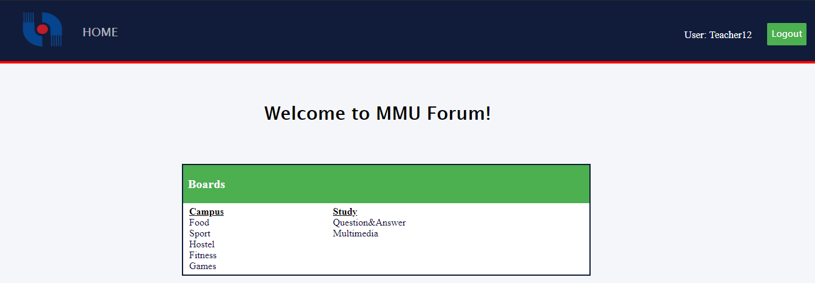

*Figure 5.5: Homepage.*

This is a homepage (mmuforum.php) where user can log in/log out and also register their account. This page also provide links to other boards.

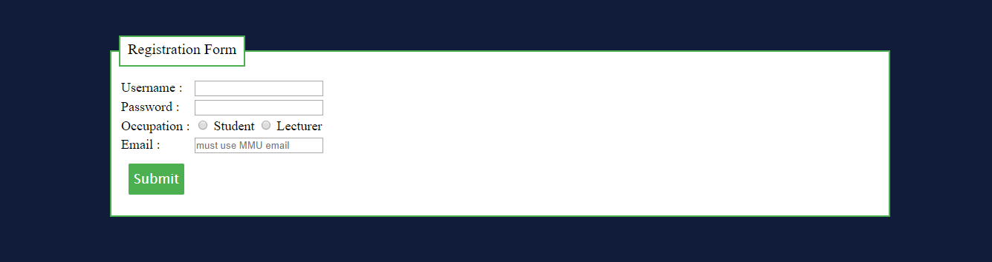

*Figure 5.6: Registration page.*

This is a page for user registration. There are four required inputs, Username, Password, Occupation and Email. Occupation will determine the type of account (Student or lecturer). Account type will be stored in field “account_type” in the database by using numbers, 0 for student, 1 for lecturer and 2 for admin. Only MMU emails are allowed to register and it must be unique, no used email.

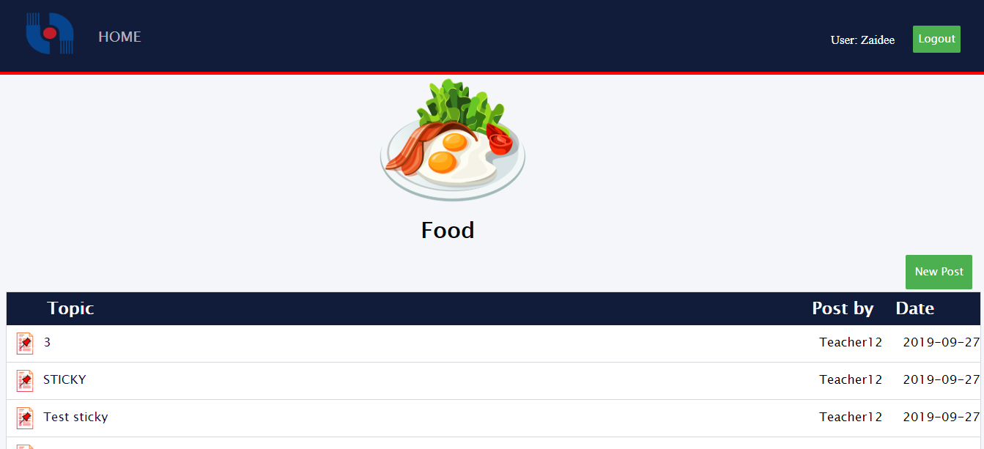

*Figure 5.7: Board page (Food)*

This is a board page for food category. User can make a new post by pressing on “New Post” button on the right of the screen and if the user is a “lecturer” or “admin”, they will have an option to sticky their post.

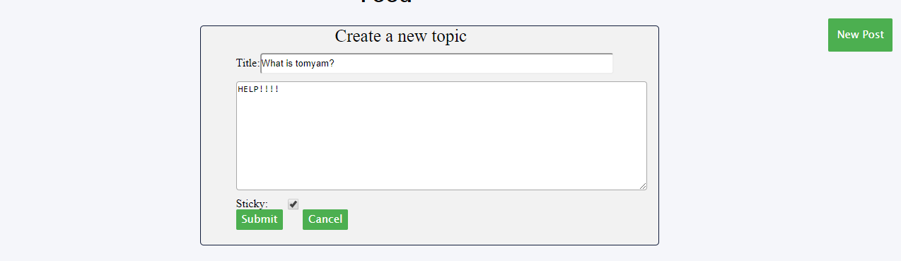

*Figure 5.8: Create a new topic form.*

When user clicked on the “New Post” button this form will show up. User then can enter the title and contents for their topic. User will also be able to sticky their post, However only lecturer and admin are authorized to use this function.

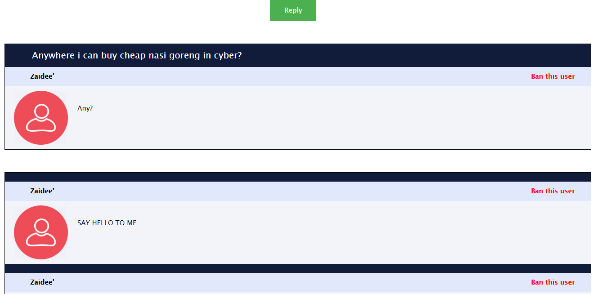

*Figure 5.9: Inside a topic*

This is what the user will see inside the topic. The top most reply is the original poster or the user that made this post/topic. User can click on the reply button to make a new reply (Figure 5.10). If the user is admin, they will be able to ban any user by clicking on the red “Ban this user” link on the right top corner of that user’s reply.

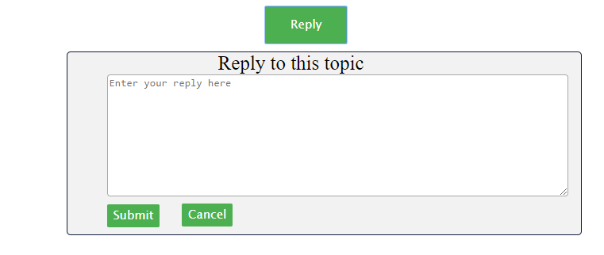

*Figure 5.10: Reply form.*



*Figure 5.11: Banned page.*

If the user is banned by the admin, they will be redirected to this page if they tried to access any of the board.

**CHAPTER 6 CONCLUSION**

In conclusion, this project aims to create a web application that allow student and lecturer to share, learn, help and communicate with each other. User will be able to post and make a reply. Admin and lecturer will be able to sticky their post. We also aimed to create an app that has a user friendly interface with reliable and high performance system. Lastly, we hope that this application will help MMU student and lecturer to be able communicate and discuss with each other more than ever before.